ASSIGNMENT 4

Name: C.Abirami TEAM ID: PNT2022TMID06179

Ultrasonic sensor simulation in Wokwi

Question: Write a code and connections in wokwi for the ultrasonic sensor. Whenever the distance is less than 100cms send an “Alert” to IBM cloud and display in the device recent events.

#include <WiFi.h> #include <PubSubClient.h> void callback(char* subscribetopic, byte* payload, unsigned int payloadLength);

//-------credentials of IBM Accounts------

#define ORG "9lxobn"//IBM ORGANITION ID

#define DEVICE_TYPE "ESP32PROJECT"//Device type mentioned in ibm watson IOT

Platform

#define DEVICE_ID "ESP32"//Device ID mentioned in ibm watson IOT Platform

#define TOKEN "ESP32PROJECT" //Token String data3; char server[] = ORG ".messaging.internetofthings.ibmcloud.com"; char publishTopic[] = "iot-2/evt/Data/fmt/json"; char subscribetopic[] = "iot-2/cmd/test/fmt/String"; char authMethod[] = "use-token-auth"; char token[] = TOKEN;

char clientId[] = "d:" ORG ":" DEVICE_TYPE ":" DEVICE_ID;

WiFiClient wifiClient;

PubSubClient client(server, 1883, callback ,wifiClient); const int trigPin = 5; const int echoPin = 18; #define SOUND_SPEED 0.034 long duration; float distance; void setup() { **Serial**.begin(115200); pinMode(trigPin, OUTPUT); pinMode(echoPin, INPUT); wificonnect(); mqttconnect();

} void loop() { digitalWrite(trigPin, LOW); delayMicroseconds(2); digitalWrite(trigPin, HIGH); delayMicroseconds(10); digitalWrite(trigPin, LOW); duration = pulseIn(echoPin, HIGH); distance = duration * SOUND_SPEED/2;

**Serial**.print("Distance (cm): "); **Serial**.println(distance); if(distance<100)

{

**Serial**.println("ALERT!!"); delay(1000); PublishData(distance); delay(1000); if (!client.loop()) { mqttconnect();

} } delay(1000); } void PublishData(float dist) { mqttconnect();

String payload = "{\"Distance\":"; payload += dist; payload += ",\"ALERT!!\":""\"Distance less than 100cms\""; payload += "}";

**Serial**.print("Sending payload: "); **Serial**.println(payload);

if (client.publish(publishTopic, (char*) payload.c_str())) {

**Serial**.println("Publish ok");

} else {

**Serial**.println("Publish failed");

} } void mqttconnect() { if (!client.connected()) {

**Serial**.print("Reconnecting client to "); **Serial**.println(server);

while (!!!client.connect(clientId, authMethod, token)) { **Serial**.print("."); delay(500); }

initManagedDevice();

**Serial**.println();

} } void wificonnect() {

**Serial**.println();

**Serial**.print("Connecting to "); WiFi.begin("Wokwi-GUEST", "", 6); while (WiFi.status() != WL_CONNECTED) { delay(500);

**Serial**.print(".");

}

**Serial**.println("");

**Serial**.println("WiFi connected");

**Serial**.println("IP address: ");

**Serial**.println(WiFi.localIP());

} void initManagedDevice() {

if (client.subscribe(subscribetopic)) { **Serial**.println((subscribetopic));

**Serial**.println("subscribe to cmd OK");

} else {

**Serial**.println("subscribe to cmd FAILED");

} } void callback(char* subscribetopic, byte* payload, unsigned int payloadLength) {

**Serial**.print("callback invoked for topic: "); **Serial**.println(subscribetopic); for (int i = 0; i < payloadLength; i++) { //Serial.print((char)payload[i]); data3 += (char)payload[i];

}

**Serial**.println("data: "+ data3); data3="";

}

Diagram json

{

"version": 1,

"author": "Abirami.",

"editor": "wokwi",

"parts": [

{ "type": "wokwi-esp32-devkit-v1", "id": "esp", "top": 23.33, "left": -106,

"attrs": {} },

{ "type": "wokwi-hc-sr04", "id": "ultrasonic1", "top": -15.04, "left": 86.5,

"attrs": {} }

],

"connections": [

[ "esp:TX0", "$serialMonitor:RX", "", [] ],

[ "esp:RX0", "$serialMonitor:TX", "", [] ],

[ "ultrasonic1:VCC", "esp:VIN", "red", [ "v168.58", "h-279.11", "v-66" ] ],

[ "ultrasonic1:GND", "esp:GND.1", "black", [ "v0" ] ],

[ "ultrasonic1:TRIG", "esp:D5", "green", [ "v0" ] ],

[ "ultrasonic1:ECHO", "esp:D18", "green", [ "v0" ] ]

]

}

libraries.txt:

# Wokwi Library List

# See https://docs.wokwi.com/guides/libraries

PubSubClient

Library Manager:

Installed Libraries:

PubSubClient

Wokwi simulation link:

https://wokwi.com/projects/347580348160279122

Circuit diagram:

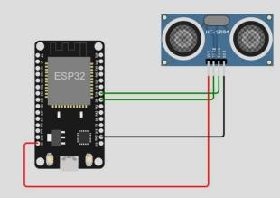

Output:

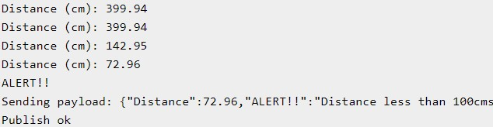

IBM cloud output

